Institute of Postgraduate Legal Studies
Phone number: +36 1 318-5912
batho.roberta@ajk.elte.hu
Table of Contents
1
.
Welcome note................................................................................................................................. 2
Enrolment for the Master program in International and European Taxation Law.................. 3
First semester................................................................................................................................. 4
Active period: ............................................................................................................................. 4
Course registration..................................................................................................................... 4
Subjects of the first semester:.................................................................................................... 6
First day of teaching .................................................................................................................. 6
Information about exams and teaching material .................................................................... 6
2
3
3
3
3
3
3
3
4
4
4
4
4
4
4
6
7
8
9
.
.
.1
.2
.3
.4.
.5.
.5.1 General information about the exam........................................................................................ 7
.
Second semester............................................................................................................................. 7
.1. Active period:................................................................................................................................... 7
.2. Course registration.......................................................................................................................... 7
.3. Subjects of the second semester: ................................................................................................. 10
.4.
First day of teaching ................................................................................................................ 11
Information about exams and teaching material .................................................................. 11
General information about the exam.................................................................................. 11
.5.
.5.1.
.
.
Student ID .................................................................................................................................... 12
Thesis requirements for the Master program in International and European Taxation Law 13
State exam .................................................................................................................................... 15
Library .......................................................................................................................................... 16
Contact...................................................................................................................................... 17
Housing - Finding your private accommodation.................................................................. 18
.
.
1
0.
1.
1
Eötvös Loránd University Faculty of Law Egyetem tér 1-3., 1053 Budapest, Hungary tel +36 1 266 2563 www.ajk.elte.hu/en

Institute of Postgraduate Legal Studies
Phone number: +36 1 318-5912
batho.roberta@ajk.elte.hu
1. Welcome note
It is a pleasure to welcome you at ELTE University. We are proud that you have chosen our
university as your temporary new academic environment. We hope to make your stay in Budapest
an exciting and valuable experience. Being one of the major universities in Hungary, our
university can provide you with high-quality academic teaching. We wish you a fruitful stay at
ELTE and hope that you will feel at home with us. May this be a unique experience which
inspires you to come back for a visit to Budapest and ELTE University at any time!
Eötvös Loránd University Faculty of Law Egyetem tér 1-3., 1053 Budapest, Hungary tel +36 1 266 2563 www.ajk.elte.hu/en

Institute of Postgraduate Legal Studies
Phone number: +36 1 318-5912
batho.roberta@ajk.elte.hu
2
. Enrolment for the Master program in International and European
Taxation Law
Friday, September 17, 2021, 9:00 AM
Office: Faculty building in Egyetem sqare 1-3. (in the lobby of the building you will find further information
in which room enrolment will take place)
Which documents to bring?
•
•
•
•
•
original diploma or its certified copy and a copy of the diploma
original certification of your English language or its certified copy and a copy of it
an ID photo
identity card and a copy of it
enrolment form from Neptun (see page 5)
NEPTUN System Neptun is a uniform documentation system for students and lecturers that
all students are bound to use. It is a virtual space to register for exams, to download teaching
material, to see the results of your exams. You will get a Neptun code from Educational
Management Office by mid August by e-mail. In order to get acquainted with the functioning of
Neptun, please consult the Neptun user guide at:
HWEB_EN_Neptun_u
ser_guide_for_studen
To get more information about Neptun go to: https://neptun.elte.hu/
Eötvös Loránd University Faculty of Law Egyetem tér 1-3., 1053 Budapest, Hungary tel +36 1 266 2563 www.ajk.elte.hu/en

Institute of Postgraduate Legal Studies
Phone number: +36 1 318-5912
batho.roberta@ajk.elte.hu
3
. First semester
3
.1
Active period:
1
6/09/2021 – 11/12/2021
3
.2
Course registration
You can only register for courses if you have an active status in NEPTUN. You can activate your
status yourself.
If you have Neptun code and Neptun password click on this website:
https://neptun.elte.hu/index_en.html
and follow these steps after entering the Neptun:
1
. Click on the „Administration” > „Enrollment/Registration” > you will see:
International and European Taxation Law” click on the „+” at the end of the row >
„
click on the „register”
2
. Click on the „Information” > click on the „General forms” > you will see „Beiratkozási
lap” – in Hungarian, - and click on the „+” at the end of the row > click on the „print”
(nyomtatás – in Hungarian). Please take these documents with you to the enrolment on
1
7th of September at 9 a.m. (1053 Budapest Egyetem square 1-3.
Course registration’s steps:

1
2
. Enter into the Neptun
. Click on the „Subject” > „register for subject”
Eötvös Loránd University Faculty of Law Egyetem tér 1-3., 1053 Budapest, Hungary tel +36 1 266 2563 www.ajk.elte.hu/en

Institute of Postgraduate Legal Studies
Phone number: +36 1 318-5912
batho.roberta@ajk.elte.hu
3
4
. You have to choose term: 2021/2022/1
. Point at the „All subjects” or Write the subject name for example: recent – in this case
you have to search every subject.
5
6
. Click on the „list subjects”
. You can see the subject name under the box and click on the „register”
Eötvös Loránd University Faculty of Law Egyetem tér 1-3., 1053 Budapest, Hungary tel +36 1 266 2563 www.ajk.elte.hu/en
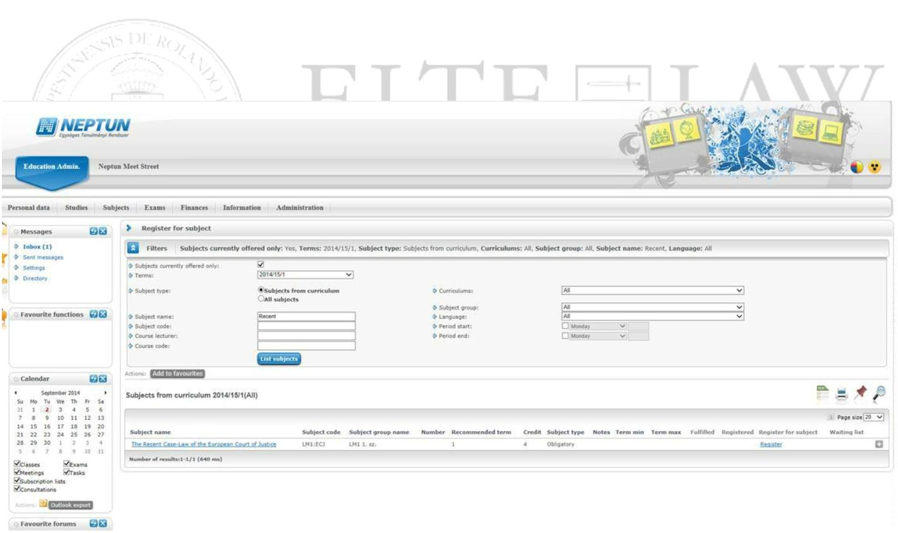
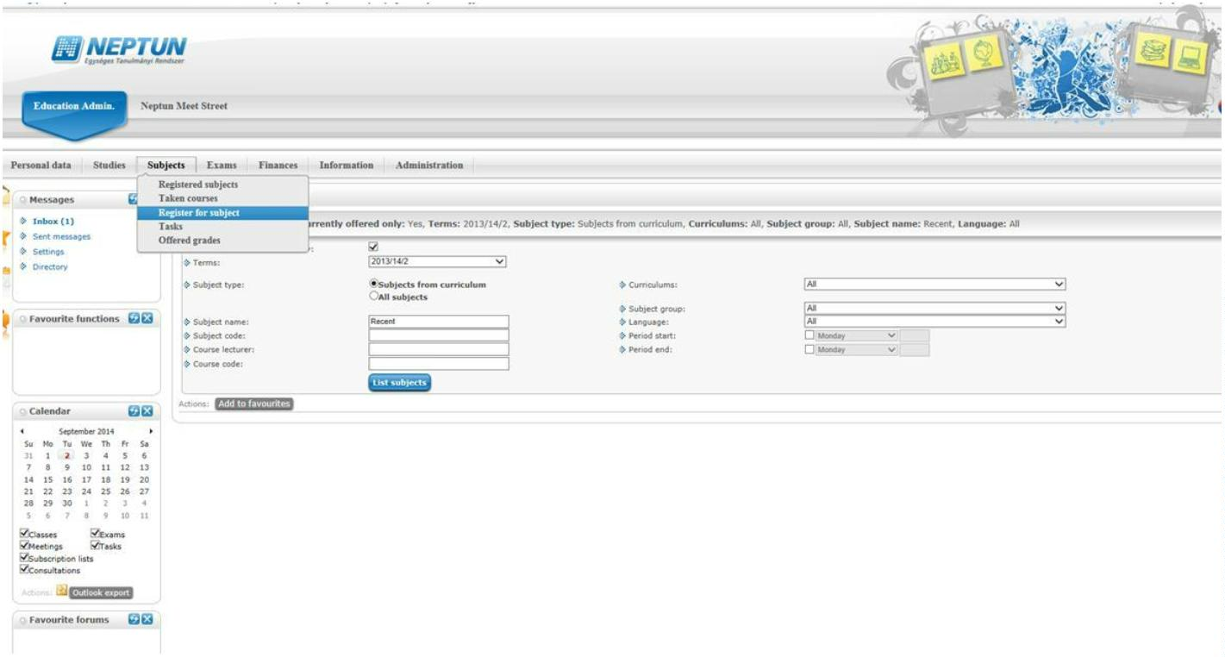

Institute of Postgraduate Legal Studies
Phone number: +36 1 318-5912
batho.roberta@ajk.elte.hu
3
.3
Subjects of the first semester:
•
•
•
•
•
Fundamentals of International Tax Law
OECD Model Tax Convention
Transfer Pricing
Economic Analysis of International Taxation for lawyers
Basics of Public International Law for economists
Alternative courses I. (it means that you can register either for the first or for the second course and can not take
both):
•
International Tax Planning in Practice
Please note that International Tax Planning in Practice is practice oriented seminar where your
presence is needed.
Please note that the number of participants for each group is limited. If the limit is reached for
the course you wanted to join you have to choose the other course.
After selecting the courses make sure that the course list is correct, print it out and keep it.
3
.4. First day of teaching
Friday, September 17, 2021, 9:00 AM

3
.5. Information about exams and teaching material
Exam period: 13/12/2021 – 28/01/2022
Eötvös Loránd University Faculty of Law Egyetem tér 1-3., 1053 Budapest, Hungary tel +36 1 266 2563 www.ajk.elte.hu/en

Institute of Postgraduate Legal Studies
Phone number: +36 1 318-5912
batho.roberta@ajk.elte.hu
For subjects of the first semester you will have 5 exams. Please note that some subjects are joint
for examination meaning that they form part of a single exam. Under the exam period the
following exams will take place:
•
•
•
•
•
Fundamentals of International Tax Law
OECD Model Tax Convention
Transfer Pricing
Economic Analysis of International Taxation for lawyers
Basics of Public International Law for economists
As International Tax Planning in Practice is seminar, you do not have to register for exam in this
subject but will receive a mark at the end of semester.
3
.5.1 General information about the exam
The latest passible time for registration is 24 hours before the exam.
For preparing to the exams you are invited to consult
•
•
reading material
ppt of courses uploaded to Neptun (not all lecturers use ppt presentations, it is the free
choice of the lecturer)
•
your notes taken during lectures
4
. Second semester
4
0
4
.1. Active period:
7/02/2022 – 14/05/2022
.2. Course registration
You can only register for courses if you have an active status in NEPTUN. You can activate your
status yourself.
Period open for course registration:
From the end of January 2022 to mid February 2022
Eötvös Loránd University Faculty of Law Egyetem tér 1-3., 1053 Budapest, Hungary tel +36 1 266 2563 www.ajk.elte.hu/en

Institute of Postgraduate Legal Studies
Phone number: +36 1 318-5912
batho.roberta@ajk.elte.hu
Course registration’s steps:
1
2
. Enter into the Neptun
. Click on the „Subject” > „register for subject”
3
4
. Opt for: 2021/2022/2
. Point at „All subjects” or Write the subject name for example: recent – in this case you
have to search every subject.
Eötvös Loránd University Faculty of Law Egyetem tér 1-3., 1053 Budapest, Hungary tel +36 1 266 2563 www.ajk.elte.hu/en
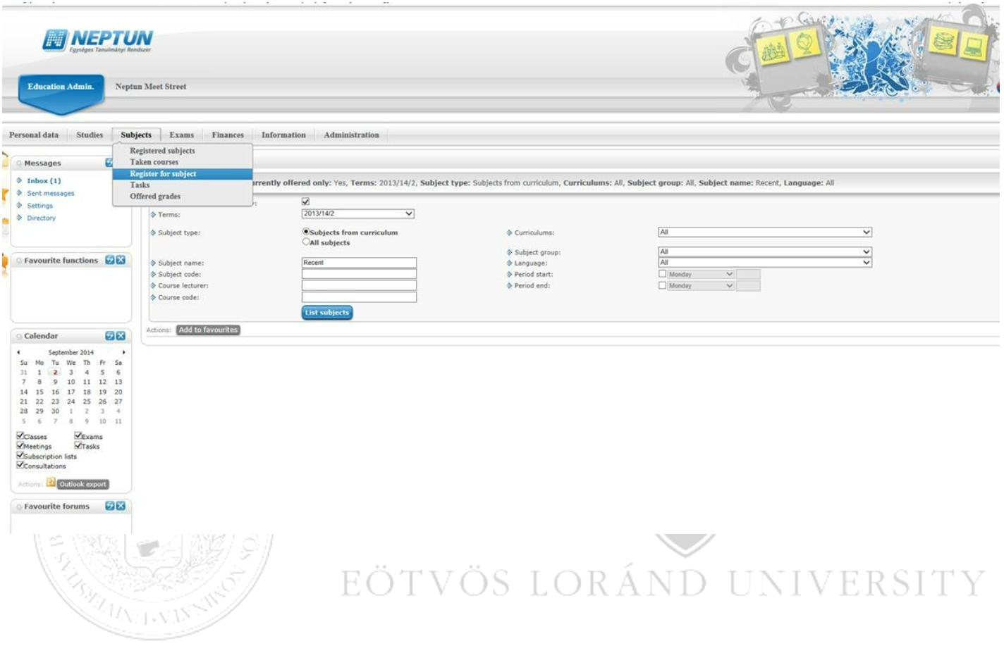
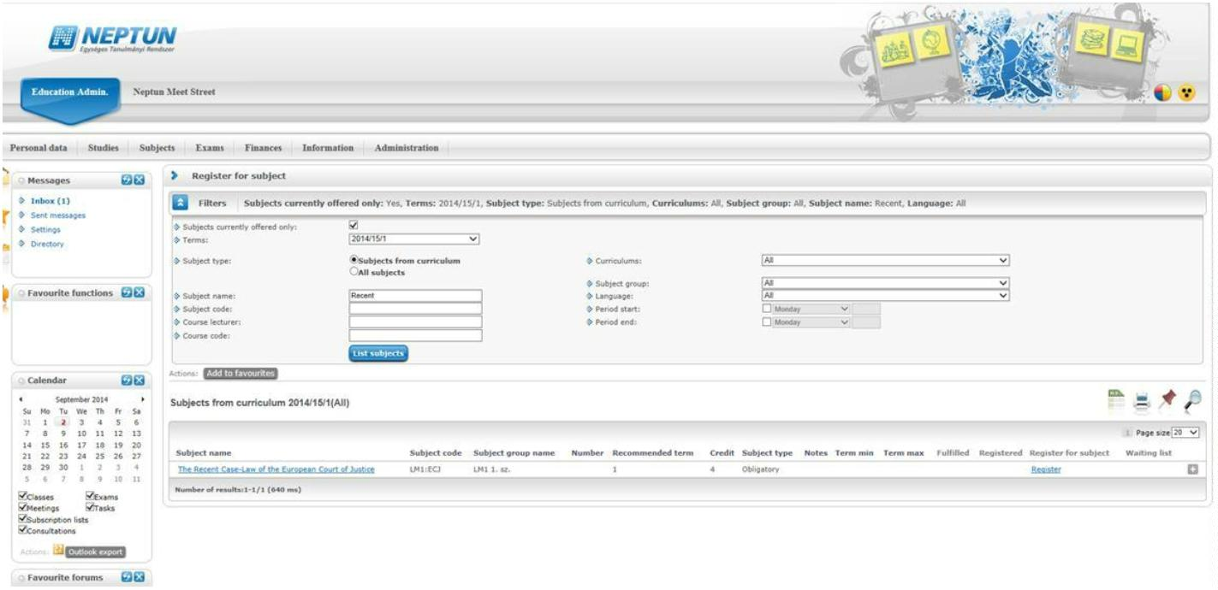

Institute of Postgraduate Legal Studies
Phone number: +36 1 318-5912
batho.roberta@ajk.elte.hu
5
6
. Click on the „list subjects”
. You can see the subject name under the box and click on the „register”
Eötvös Loránd University Faculty of Law Egyetem tér 1-3., 1053 Budapest, Hungary tel +36 1 266 2563 www.ajk.elte.hu/en

Institute of Postgraduate Legal Studies
Phone number: +36 1 318-5912
batho.roberta@ajk.elte.hu
4
.3. Subjects of the second semester:
•
•
•
•
•
Direct Taxation in the Internal Market
Fiscal State Aid Law
VAT
Introduction to Custom and Excise Duties and Energy Taxation
Bodies and Legal Sources of the EU
Elective courses I. (it means that you can register either for the first or for the second course and can take both):
•
Tax Planning within the EU
OR
•
International problems of tax optimization
Please note that the number of participants for each group is limited. If the limit is reached for
the course you wanted to join you have to choose the other course.
After selecting the courses make sure that the course list is correct, print it out and keep it.
Eötvös Loránd University Faculty of Law Egyetem tér 1-3., 1053 Budapest, Hungary tel +36 1 266 2563 www.ajk.elte.hu/en

Institute of Postgraduate Legal Studies
Phone number: +36 1 318-5912
batho.roberta@ajk.elte.hu
4
.4. First day of teaching
Friday, February 2022
4
.5. Information about exams and teaching material
The exam period: 16/05/2022 – 01/07/2022
For subjects of the second semester you will have 5 exams. Please note that some subjects are
joint for examination. Under the exam period the following exams will take place:
•
•
•
•
•
Direct Taxation in the Internal Market
Fiscal State Aid Law
VAT
Introduction to Custom and Excise Duties and Energy Taxation
Bodies and Legal Sources of the EU
As Tax Planning within the EU and International problems of tax optimization are seminars, you
do not have to register for exam in these subjects but will receive a mark at the end of semester.
4
.5.1. General information about the exam
The latest possible time for registration is 24 hours before the exam.
For preparing to the exams you are invited to consult
•
•
reading material
ppt of courses uploaded to Neptun (not all lecturers use ppt presentations, it is the free
choice of the lecturer)
•
your notes taken during lectures
5
. Tuition fee for the Master program in International and European
Taxation Law 2021/2022
Eötvös Loránd University Faculty of Law Egyetem tér 1-3., 1053 Budapest, Hungary tel +36 1 266 2563 www.ajk.elte.hu/en

Institute of Postgraduate Legal Studies
Phone number: +36 1 318-5912
batho.roberta@ajk.elte.hu
The tuition fee for the 2021/2022th academic year is 325,000 HUF/semester. The fee for the
first semester is to be paid not later than 15 October 2021. The fee for the second semester is to
be paid not later than 15 March 2022.
PAYMENT
Bank Transfer - from any bank account to the ELTE’s Collector account.
How to do the transfer:
1
. All money has to be transferred to the Collector account of ELTE. You can find your
invoice in Neptun. Your invoice includes details about your options for making a
payment.
2
3
. A message informs you about the success of the transfer (The transferred money appears
in the Neptun in 1-2 days under https://neptun.elte.hu->Finances->Payment)
. You have to approve the transfer. After the amount appears, you have to check the
square which is next to your dues, then click on ’next’, and then on ’pay in’ – if you have
the message ’Successful payment’, then the payment is done.
Contact: quaestura@quaestura.elte.hu
6
. Student ID
Student card application (first one or lost)
1
2
3
. You can apply for student ID at the Registration Office (in Hungarian: Okmányiroda)
. List of offices nearby: http://www.kozuleti.com/hun/hasznos.php?m=okmany
. There they will take a photo of you and register your personal data. You get a form with a
unique code on the top right corner called NEK identifier. (Just tell them you would like
to apply for a student card (in Hungarian: diákigazolvány) and they will help.
4
. You
have
to
->
register
student
to
your
card
add
application
request
your
in
Neptun:
add new
Administration
->
Here
you
have
NEK
identifier;
If you choose your Hungarian address (do this only if you have a permanent address in
Hungary with an official card) the card is going to be posted to this Hungarian address; in
Eötvös Loránd University Faculty of Law Egyetem tér 1-3., 1053 Budapest, Hungary tel +36 1 266 2563 www.ajk.elte.hu/en

Institute of Postgraduate Legal Studies
Phone number: +36 1 318-5912
batho.roberta@ajk.elte.hu
case if you give your home address (your permanent address in your country) because you
do not have an official Hungarian address - the card is going to be posted to the
Registration
Office,
where
you
applied
for
the
NEK
form.
Do not choose a second institution when you fill out the request.
5
.
The price of the card (1400 HUF) will appear on your joint account in maximum 2
weekdays. You can check this in the NEPTUN system (Finances->Payment).
6
7
. You can fulfil the payment through a transfer to
. Eötvös Loránd Tudományegyetem
IBAN: HU22 1003 2000 0142 6201 0112 0008
SWIFT: MANEHUHB
BIC: HUSTHUHB
Currency: HUF
Notice/Topic: NK- your neptun identifier code with capital letters
Amount: 1400
8
. The amount is going to be on your NEPTUN joint account in 2-3 weekdays. When it is
there (you get a system message about that) you go to Finances -> Payment here you insert
the amount and click on "pay in". After you have paid your card is hopefully ready in 2-3
months if uncomplicated. Meanwhile you can go to Questura Office (Budapest,
Ferenciek tere 6, 1053.) for a temporary student card, which is valid for 60 days, so you
may
have
to
go
for
this
more
than
once.
Should you have any additional question concerning the NEK form, contact the
Questura Office and they will help you in applying for the card.
7
. Thesis requirements for the Master program in International and
European Taxation Law
A requirement of the Master program is the submission of a thesis approved by a thesis
supervisor. The thesis supervisor must be a Faculty member or an external lecturer of the Master
program. In certain cases the Professor in charge of the Master program might authorise the
involvement of an external supervisor if justified by the specificity of the subject-matter of the
thesis.
The thesis proposal (title of the thesis) must be approved by the thesis supervisor.
Eötvös Loránd University Faculty of Law Egyetem tér 1-3., 1053 Budapest, Hungary tel +36 1 266 2563 www.ajk.elte.hu/en

Institute of Postgraduate Legal Studies
Phone number: +36 1 318-5912
batho.roberta@ajk.elte.hu
The thesis must be an independent research essay of 40 pages approximately
(80 000 typewritten characters).
Students should work with the thesis supervisor to plan a timetable for submitting drafts for
review so that the final approval can be achieved timely.
The thesis must be submitted just in electronic format (Pdf) at the
Jogi Továbbképző Intézet (JTI) to Roberta Batho after the thesis supervisor has given
her/his final written approval for the thesis.
The thesis supervisor must give a written evaluation of the thesis for the final exam.
The thesis must be defended at the final exam. At the defence you should be able to answer
questions concerning specific aspects of your thesis and present your main conclusions if needed.
Your thesis will be graded by the final examination board taking into account the grading
proposal of the thesis supervisor.
The thesis is graded from 1 to 5.
FORMATTING REQUIREMENTS OF THE THESIS
•
Use a font size of approximately 12. The only exceptions to this font size are footnotes (not
smaller than 9 point) and headings (not larger than 20 point);
•
•
•
Black text is recommended;
A table of contents is required;
Chapters should follow a logical outline, with a clear distinction between chapters and main
heads within chapters;
•
Textual notes that provide supplementary information, opinions, explanations or suggestions
that are not part of the text must appear at the bottom of the page as footnotes. The same is
applicable for references to works cited;
•
•
A bibliography, references, or works cited is required;
Any of the standard style manuals may be used as a guide in formatting references to works
cited in the thesis.
You have to fill in the Declaration of Originality form.
Eötvös Loránd University Faculty of Law Egyetem tér 1-3., 1053 Budapest, Hungary tel +36 1 266 2563 www.ajk.elte.hu/en

Institute of Postgraduate Legal Studies
Phone number: +36 1 318-5912
batho.roberta@ajk.elte.hu
8
. State exam
In order to be admitted to the state exam you have to
•
•
have acquired all 55 credits
have submitted your thesis approved by your supervisor
The state exam is composed of three parts:
•
•
Defence of the thesis
Oral exam in internal market law (free movement of goods, persons, services and capital,
competition law)
Oral exam in transnational commercial law (regulation of contracts for the international
sale of goods, international and European harmonisation of contracts, international
commercial arbitration, the law of multinational enterprises)
Eötvös Loránd University Faculty of Law Egyetem tér 1-3., 1053 Budapest, Hungary tel +36 1 266 2563 www.ajk.elte.hu/en

Institute of Postgraduate Legal Studies
Phone number: +36 1 318-5912
batho.roberta@ajk.elte.hu
9
. Library
The Library's resources are available for students of the Master program. There is a selection of
recently published books in European or International business law ordered especially for this
program. Please remember to carry your ID card with you at all times.
Opening hours
Monday:
Tuesday:
Wednesday:
Thursday:
Friday:
9.00-19.00
9.00-19.00
9.00-19.00
9.00-19.00
9.00-16.00
9.00-16.00
Closed
Saturday:
Sunday:
Address: 1053 Budapest Egyetem tér 1-3 Ground floor
http://konyvtar.elte.hu/web/en/node/479
Eötvös Loránd University Faculty of Law Egyetem tér 1-3., 1053 Budapest, Hungary tel +36 1 266 2563 www.ajk.elte.hu/en

Institute of Postgraduate Legal Studies
Phone number: +36 1 318-5912
batho.roberta@ajk.elte.hu
1
0. Contact
The general contact – Roberta Batho - will help you to succeed in your Master studies.
You can find her in Jogi Továbbképző Intézet, room 303, 3rd floor in the „A” Building Egyetem
tér 1-3 Budapest 1053.
Roberta Batho
General contact - JTI
Technical issues regarding the programme
Room 303, 3rd floor, „A” building Egyetem tér 1-3 Budapest 1053
batho.roberta@ajk.elte.hu
Eötvös Loránd University Faculty of Law Egyetem tér 1-3., 1053 Budapest, Hungary tel +36 1 266 2563 www.ajk.elte.hu/en

Institute of Postgraduate Legal Studies
Phone number: +36 1 318-5912
batho.roberta@ajk.elte.hu
11. Housing - Finding your private accommodation
Partner real estate agencies: Please have a look at the list of our partner real estate agencies and
some basic information about them. These agencies help you find the right place for your stay in
Budapest. When you contact the agencies, please mention that you are a student at ELTE. Please
note that the amounts given are rough estimates of the rental fee without any utility costs.
1
2
3
4
5
. www.huniversity.hu, e-mail: info@huniversity.hu
(Room, flat and flatmate finding very reliable company)
. www.srs-budapest.hu, e-mail: info@srs-budapest.hu
(Rooms and flats available at around 200-230 EUR per person per month)
. http://ihomes.hu/, e-mail: flat4rent.budapest@gmail.com
(Rooms and flats available at around 200-250 EUR per person per month)
. http://www.studenthousing.hu/
(Rooms and flats available at around 300 EUR per person per month)
. www.tower-rentals.com, e-mail: info@tower-rentals.com
(Flats available at around 400-600 EUR per flat per month)
If you are a doctoral student and you are staying in Budapest only for a short period of time, you
may contact the following real estate agency:
www.hospitalityinbudapest.com, e-mail: info@hospitalityinbudapest.com
(Studios and 1-2-3-bedroom flats available for short term - from 3 nights to 2 months - at
around 40 EUR per flat per night or 300-400 EUR per flat per month)
For a short stay:
As a temporary solution, you may contact the following hostel. In order to get a discount,
please do not forget to mention that you are a guest student at ELTE University:
www.casadelamusicahostel.com, e-mail: hostel@casadelamusica.hu
(Bed available for 6-5-7 EUR per person per night)
The hostel and the agencies can provide you with all information in English.
Dormitory
rooms
for
the
whole
semester:
In addition, our university offers dormitory rooms designed for two persons (at around 120-150
Eötvös Loránd University Faculty of Law Egyetem tér 1-3., 1053 Budapest, Hungary tel +36 1 266 2563 www.ajk.elte.hu/en

Institute of Postgraduate Legal Studies
Phone number: +36 1 318-5912
batho.roberta@ajk.elte.hu
EUR per person per month). Please note that this option is only available for a whole semester
and the number of places is limited. If you are interested in this possibility, please contact Prof.
Dr. Tibor Seifert, the Director General of the Dormitories via email at seifert@kollegium.elte.hu.
Dormitory information: http://www.ajk.elte.hu/en/studying_here/accommodation
We are looking forward to meeting you at ELTE!
Eötvös Loránd University Faculty of Law Egyetem tér 1-3., 1053 Budapest, Hungary tel +36 1 266 2563 www.ajk.elte.hu/en

